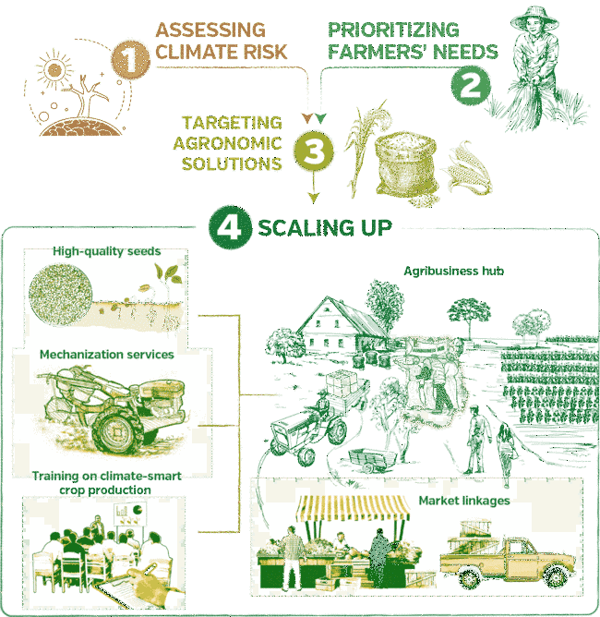Solution architecture for fertilizers recommendation system for disease prediction